**ECE 20100 – Fall 2016**

**Exam #3**

**November 30, 2016**

**Sections (include on scantron)**

Hosseini (9:30) – 0002 Peleato-Inarrea (3:30) – 0004 Michelusi (1:30) – 0005

Qi (10:30) – 0011 Cui (8:30) – 0012

Peroulis (11:30) – 0013 Kildishev (1:30) – 0014

Name ____________________________ PUID____________

***Instructions***

1. DO NOT START UNTIL TOLD TO DO SO.
2. Write your name, section, professor, and student ID# on your **Scantron** sheet. We may check PUIDs.
3. This is a CLOSED BOOKS and CLOSED NOTES exam.
4. The use of a TI-30X IIS calculator is allowed, but not necessary.
5. If extra paper is needed, use the back of test pages.
6. Cheating will not be tolerated and will be dealt with according to the policy in your section. In particular, **continuing to write after the exam time is up is regarded as cheating**.
7. If you cannot solve a question, be sure to look at the other ones, and come back to it if time permits.
8. ***All of the problems*** on Exam #3 provide evidence for satisfaction of this ECE 20100 Learning Objective:

iii) An ability to analyze 2nd order linear circuits with sources and/or passive elements.

The minimum score needed to satisfy this objective will be posted on Blackboard after the exam has been graded. Remediation options will be posted in Blackboard if you fail to satisfy any of the course outcomes.

**By signing the scantron sheet, you affirm you have not received or provided assistance on this exam.**

**Question 1**

For t < 0 sec, vC = 0 V. The switch opens at t = 0 sec. Find vC at t = π/2 sec.

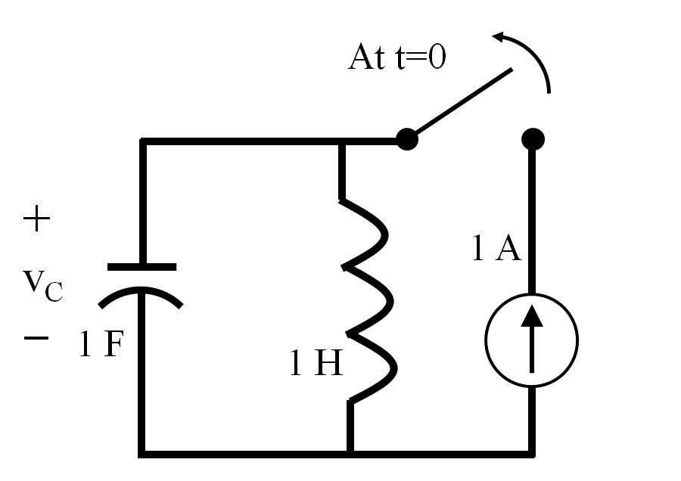

1. -4 V
2. -3 V
3. -2 V
4. -1 V
5. 0 V
6. 1 V
7. 2 V
8. 3 V
9. 4 V

**Question 2**

Which of the following values of C would make the circuit below OVERDAMPED for BOTH positions of the switch?

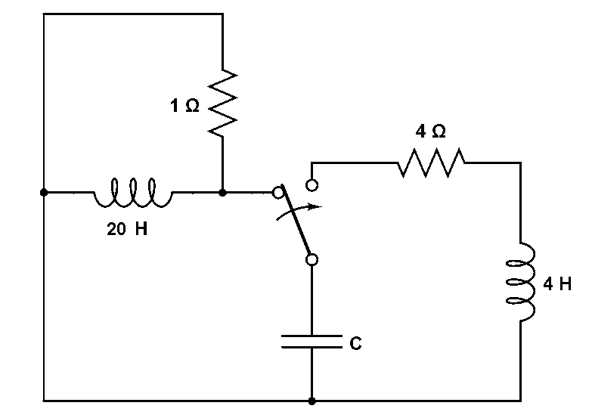

1. C = 0.1 F
2. C = 0.25 F
3. C = 0.5 F
4. C = 0.75 F
5. C = 1 F
6. C = 2 F
7. C = 5 F
8. C = 10 F
9. C = 50 F
10. None of the above

**Question 3**

In the following circuit, the switch has been open for a long time and closes at time t = 0. Find the expression which best represents how the current *iL(t)* through the inductor (in A) behaves when t ≥ 0 s.

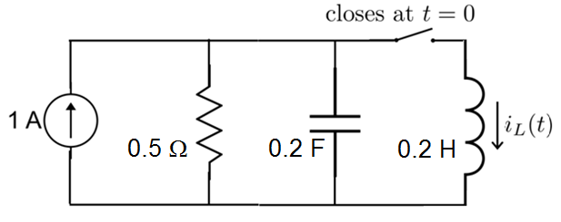

1) -1 + (Acosdt + Bsindt)e-t

2) -1 + (A + Bt)e-t

3) -1 + (Ae-t + Be-2t)

4) 1 + (Acosdt + Bsindt)e-2t

5) 1 + (A + Bt)e-2t

6) 1 + (Ae-t + Be-2t)   
7) 1 + (Acosdt + Bsindt)e-5t

8) 1 + (A + Bt)e-5t

9) 1 + (Ae-5t + Be-2t)

10) None of the above

**Question 4**

In the circuit below, find the current through the 500 Ohm resistor in the direction shown.

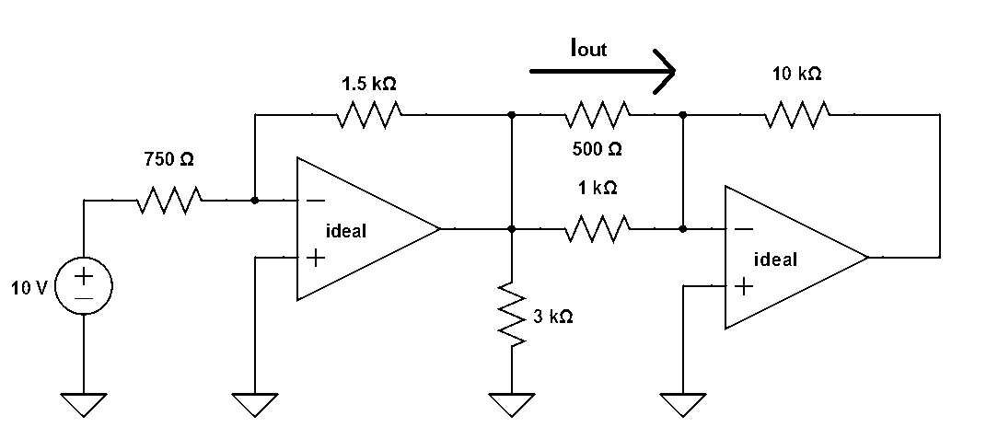

1. – 50 mA
2. – 40 mA
3. – 20 mA
4. – 10 mA
5. 0 A
6. 10 mA
7. 20 mA
8. 30 mA
9. 40 mA

None of the above

**Question 5**

For the circuit in the figure below choose an output voltage diagram from the options below, given the input voltage in the figure on the right.



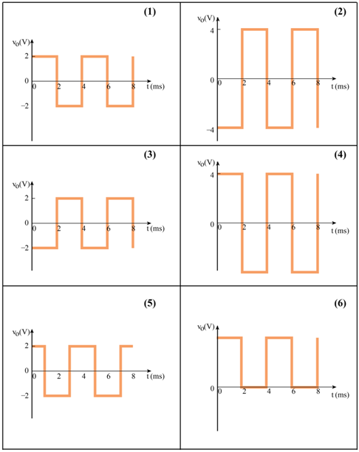

**Question 6**

In the following circuit, find the output voltage, *VAB* (in V):



1. 9 V
2. 7 V
3. 4.5 V
4. 3.5 V
5. 0 V
6. -3.5 V
7. -4.5 V
8. -7 V
9. -9 V
10. none of the above

**Question 7**

The complex exponential forcing function in a circuit operating in sinusoidal steady state is given by V. What is the corresponding real forcing function?

1. V
2. V
3. V
4. V
5. V
6. V
7. V
8. V
9. None of the above

**Question 8**

Find the phasor below that represents the voltage V:

1. 5 V
2. 1 V
3. –1 V
4. 2 + 3j V
5. 2 – 3j V
6. –2 + 3j V
7. –2–3j V
8. 3j V
9. None of the above

**Question 9**

Find the input impedance **Z**in of the circuit in the figure below. Assume that the circuit operates at ω = 50 rad/s.



1. Zin = 2 + j10
2. Zin = 2 – j10
3. Zin = 4 – j10
4. Zin = 4 + j10
5. Zin = 8 – j2
6. Zin = 8 + j10
7. Zin = 8 – j10
8. None of the above

**Question 10**

Given the following pair of voltage and current:

*v*(t)*=* 550 sin(10t*+* 40°) V, *i(t)=* 11 sin(10*t -*50°) A

in the circuit below, what is most likely the element “Z” ?

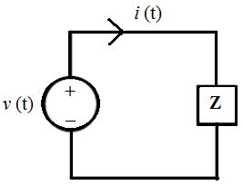

1) L = 0.2 H

2) C = 2 mF

3) L = 2 mH

4) C = 5 F

5) R = 50 ohm

6) L = 5 H

7) C = 500 F

8) None of the above

**Question 11**

Given the phasor voltages V1, V2 and V3 below, determine the phasor voltage across the capacitor as shown on the circuit below.



1) 1∠ 0 o V

2) 1∠ 180o V

3) 2√2∠ 225 o V

4) -2√2∠ 225 o V

5) 1-2√2∠ 45 o V

6) 1-2√2∠ 225 o V

7) 2(1-√2)∠ 225 o V

8) None of the above

**Potentially Useful Formulas**

First order circuit: ,  = L/R or  = RC

Series RLC: 

Parallel RLC: 







, where 









1. (4)
2. (6)
3. (8)
4. (2)
5. (3)
6. (6)
7. (4)
8. (5)
9. (2)
10. (6)
11. (1)